Social life and fun in 1.x

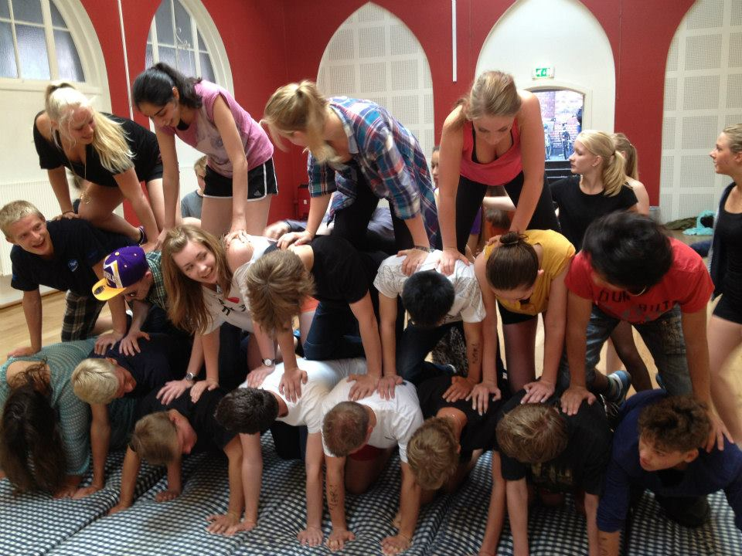

The first days at Rysensteen gymnasium
The 15th august 2012 was a beautiful day. A lot of young and happy people got together in front of Rysensteen Gymnasium. And what we didn’t know was, that some of these people were about to become our new best friends.
We were brought up in our class and were welcomed by some older students, whose job was to give us the best start at the new school.
The following days the focus was not on making us wiser but more about getting us to know each other. The older students had prepared some entertainment and some come-together-games.
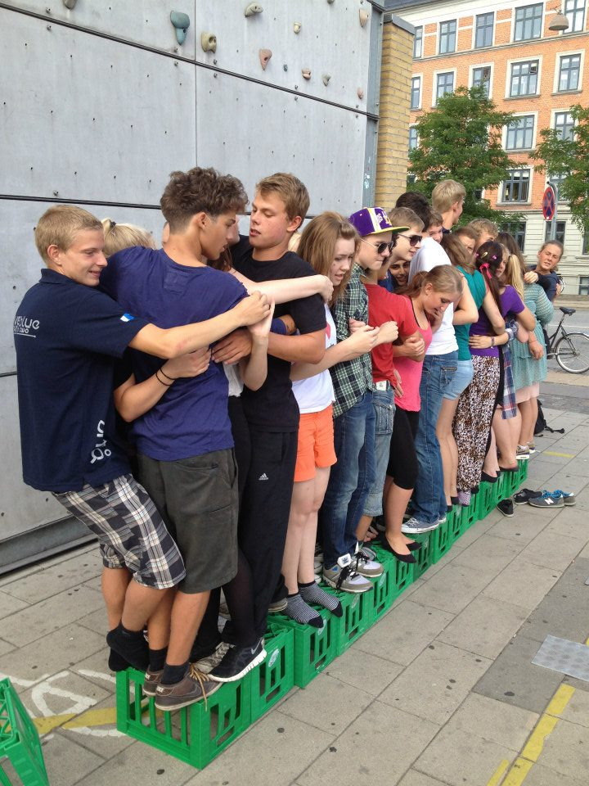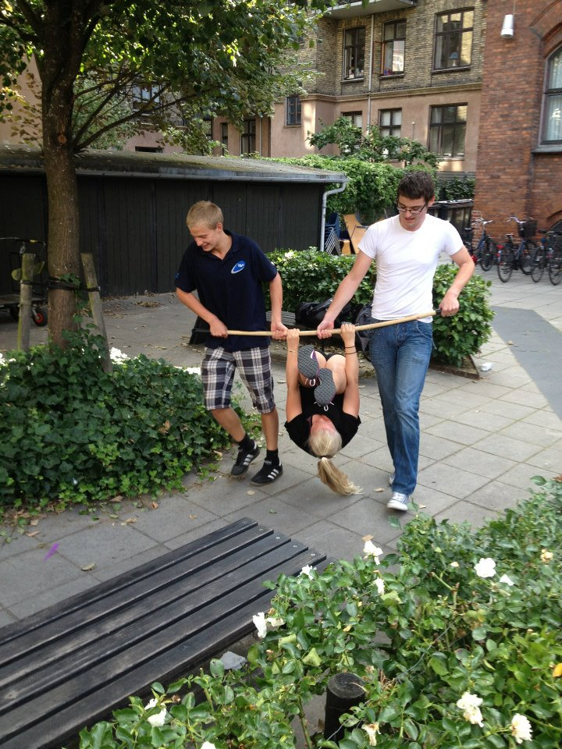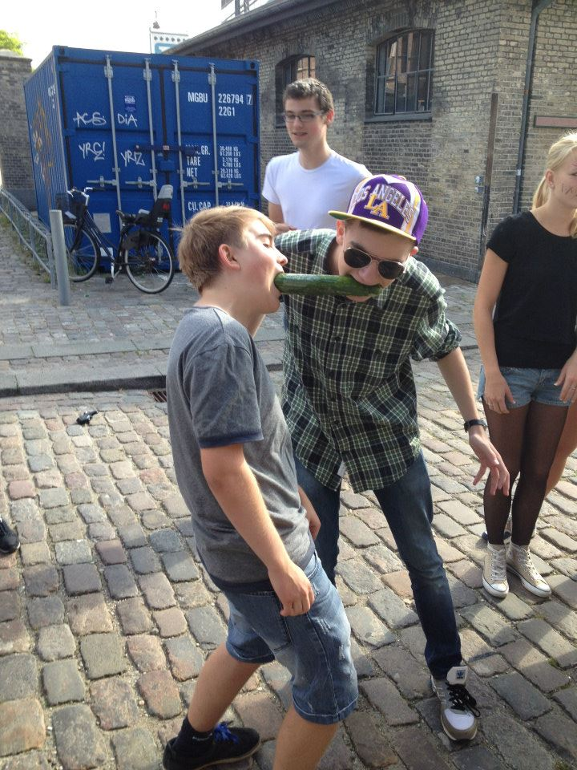

“Dyrehaven” (a big park)
In Copenhagen, there is a tradition, which says, that all the older students are allowed to paint new students, who they call “puttere” on their bodies.
In our school and many other schools in Copenhagen, it is also a tradition to go to a park called “dyrehaven”. And that is what we did. There we had fun and got to know each other by drinking a lot of beers and chatting.

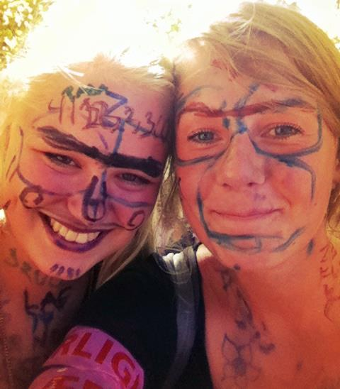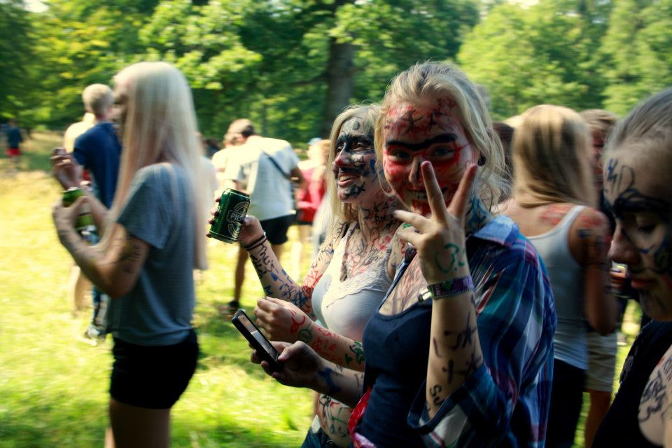

A short get-together-trip to Sweden
The time had come, the class was about to leave Copenhagen and go to Sweden, to a place called Wressel where we should stay for one night. We travelled with bus and arrived at midday, and were all very hungry when we came. So we ate our lunch, and after we went to a lake near by the cottage where we lived.
The weather was very good, the sun was shinning and there were no clouds in the sky. So we went swimming for a long time- as you see, we had a great time.
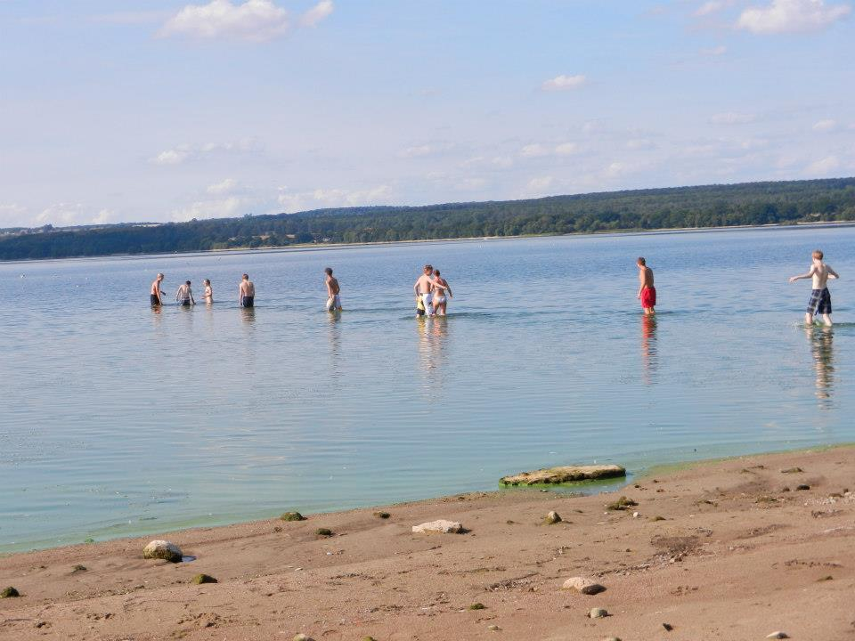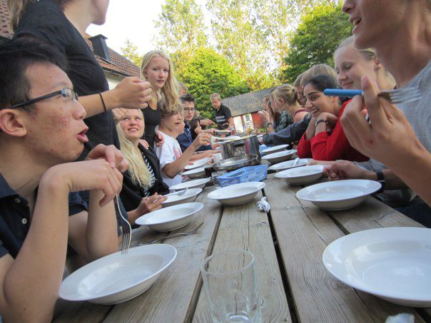
When we came home to our cottage, it was almost time for dinner, so the dinner-team (all students were on a team, and each team had a special job to do. E.g. make dinner or breakfast)
At night we made a bonfire. It was very cosy. We played some games, so we got to know each other and one called Jonas had brought his guitar, so he played some songs.
Most of us stayed up late, and didn’t even sleep that night, and if you did, you were being painted in your face while you were asleep. So most tried to stay awake.
The following day, we were all very tired, so not many words were said. Especially, not on the way back home in the bus.
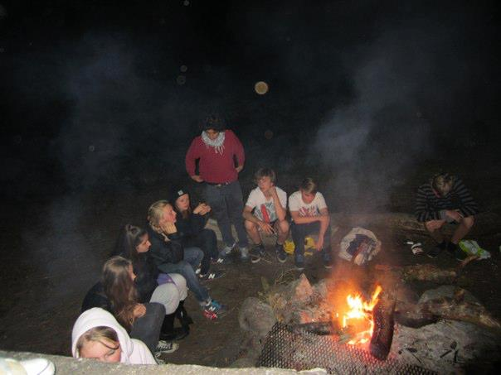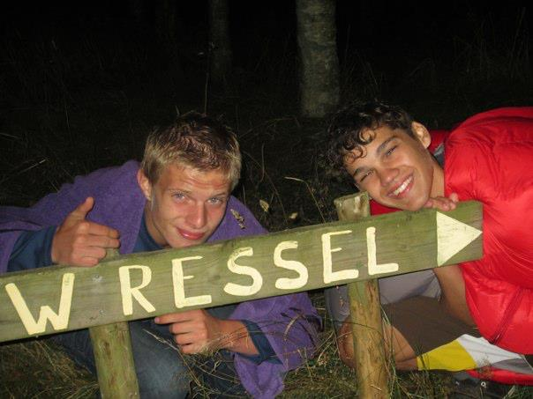

First party at the new gymnasium
Before the party, our class had dinner, where every student in the class had to bring a dish. We ate together and afterwards we played some games where we got to know each other. And then the party we all had waited for began. We danced, had fun and some hooked up. It was a wonderful night.
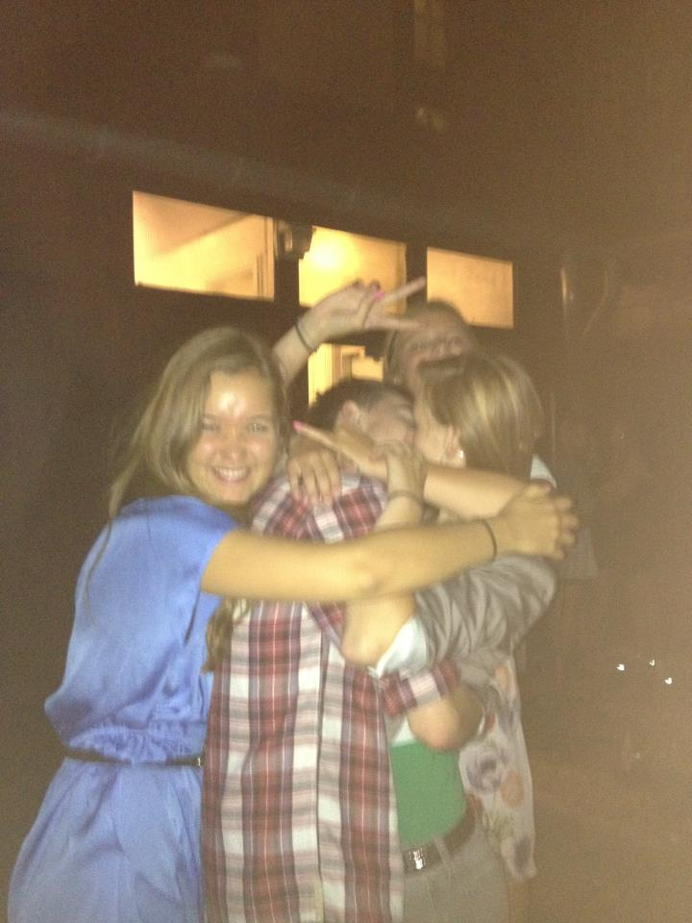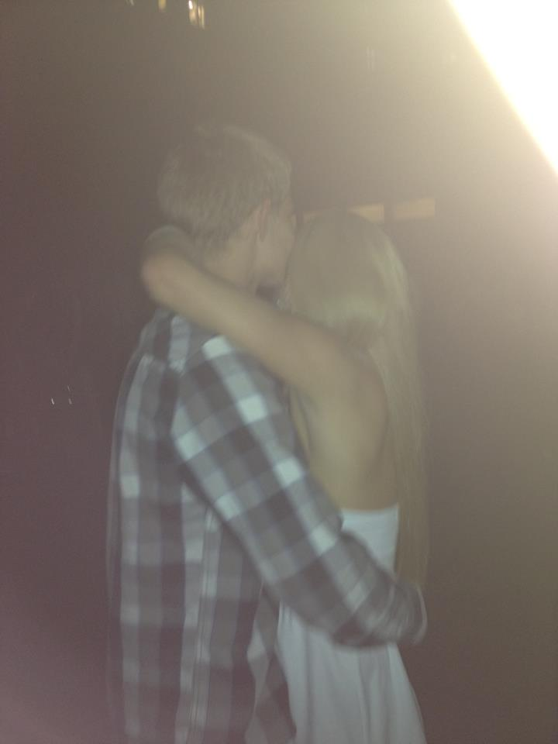

“Basement-night”
At Rysensteen gymnasium there is one evening every second month where all classes get together and chill out, that evening is called “basement-night”.
At the first basement-night, all first year students of the Danish high school system at Rysensteen gymnasium were told to prepare a show, which should be presented for the entire school. Then some of the older students should decide, which class had made the best show. And guess what- we won!

Go watch the show, it’s link below..
http://www.youtube.com/watch?v=ZIT0kLqC1oQ&feature=share
“Letter-dinner”
To get to know the two other classes above us, who also have biotechnology as one of their main subjects. We gathered and ate some food, played some games and had a lot of fun.

