Places we love <3
Let us make this one thing clear: Copenhagen is definitely about the most awesome city in the world. But what is it that makes our beloved capital so beloved? We have gathered 5 places that everyone just simply have to experience.
Behold! Avert your eyes! Hide yo kids, hde yo wife, because this is:
The list of places we love (Yes, we tried to figure out a more epic name for such an epic list, but we just couldn’t so get over it).
1) Tivoli.
Of course we start with our dear Tivoli! What can we say? Does things like the world oldest rollercoaster, party, old people with helium balloons and the circus revue (With everyone’s favourite, our one and only Johnny Reimer). There is just nothing you can’t do!
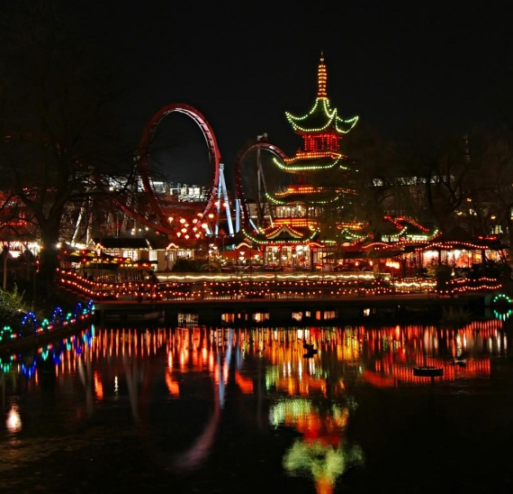
2) Sams Bar.
Japanese karaoke singers and 60 year old security guards. Two things that characterizes Sams Bar. This is the place you will (and I promise, you WILL) end up no matter what, if you’ve been drinking just a little bit too much.
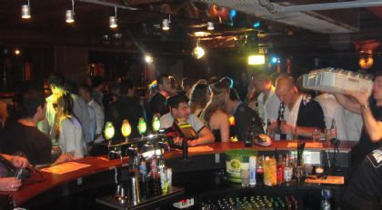
3)
Strøget.
Shopping. Shopping. And then some more shopping. Eventually finished with some shopping. Everything from Abercrombie and Fitch, to that cute polish guy in the secondhand store next door.
Make sure to bring a loaded Mastercard, or just make sure to bring some rich friends. We don’t card.
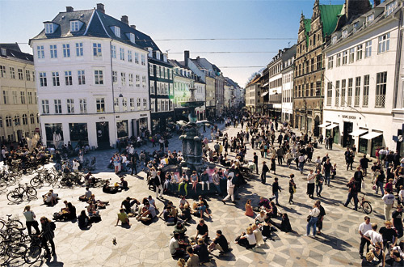
4) McDonald’s.
The almighty, the outstanding, our one and only, the super delicious and at the same time a little bit disgusting, the one who’s always there for us when we are feeling down. 10 cheeseburgers from a McDonald’s can cure about anything from hangovers, to emphysema.
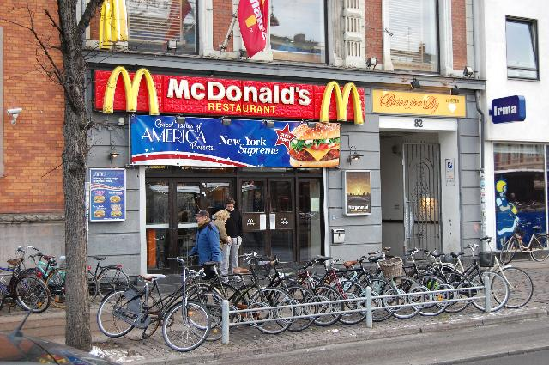
5)
Christiania.
We thought this candidate should make it for the list. It is after all, the only free haven in Denmark. And where else do you find the perfect mix of hash, rockers and old people who still thinks its hip to be hippies?
